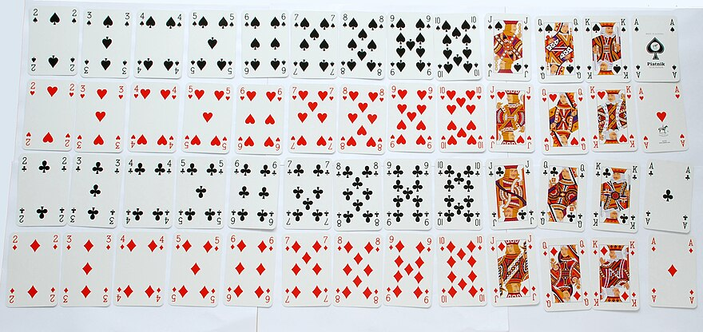

52 Cards
4 Suits:
*13 Hearts
*13 Diamonds
*13 Clubs
*13 Spades

